Layers of the Atmosphere: Name: __________________________Date:_______
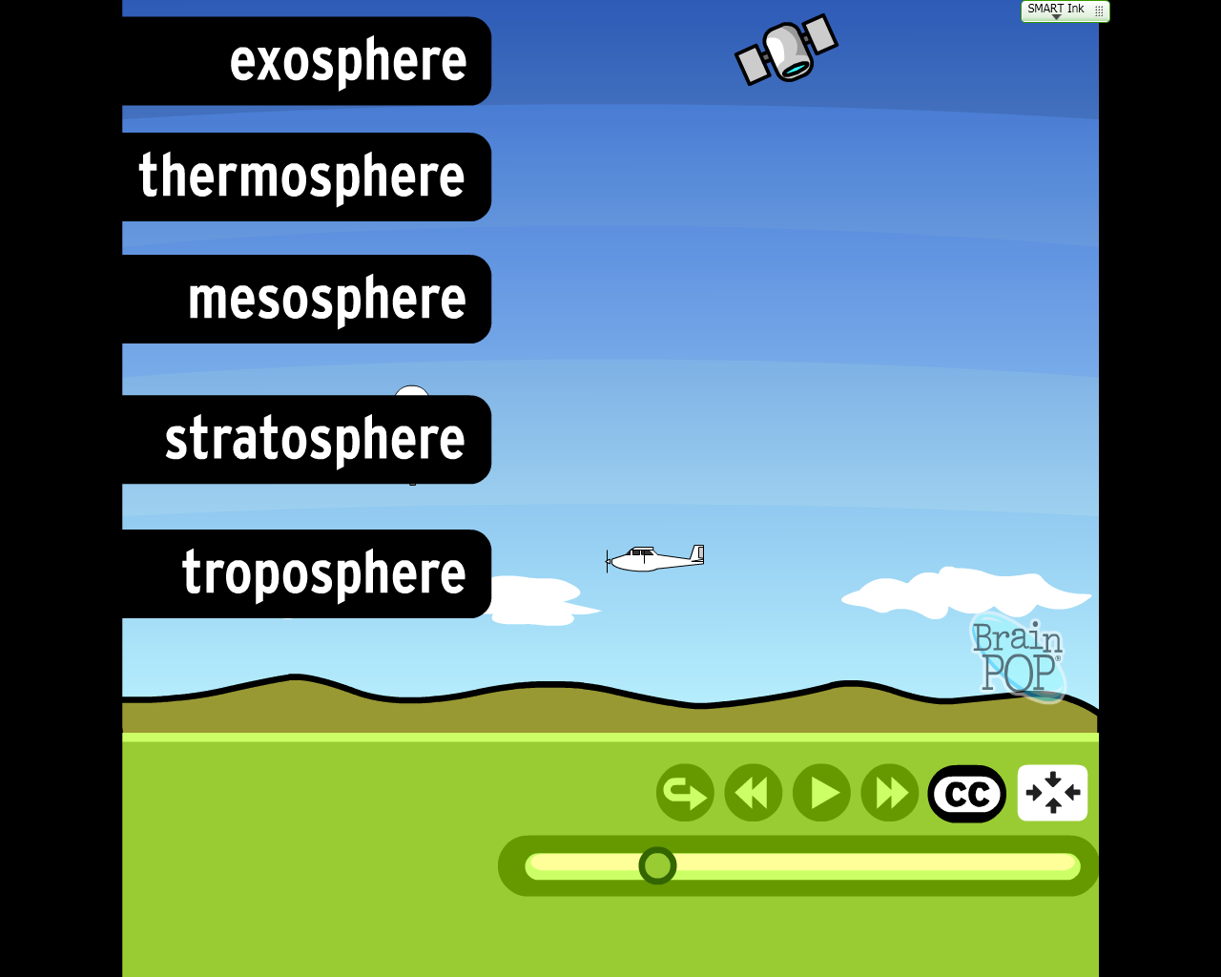
Take notes about each of the Layers as you watch the Brainpop video on the Atmosphere.

Questions:
1. Which layer do we live in?
_____________________________________________________________________________________________________
2. Which major layer contains the Ozone Layer?
_____________________________________________________________________________________________________
3. What is Ozone?
_____________________________________________________________________________________________________
4. Which layer burns up meteors as they enter our atmosphere?
_____________________________________________________________________________________________________
5. Which layer is the coldest? Hottest?
_____________________________________________________________________________________________________
6. What is the Ionosphere? And where is it located?
_____________________________________________________________________________________________________
7. Why is the sky BLUE?
_____________________________________________________________________________________________________
_____________________________________________________________________________________________________
_____________________________________________________________________________________________________
_____________________________________________________________________________________________________

