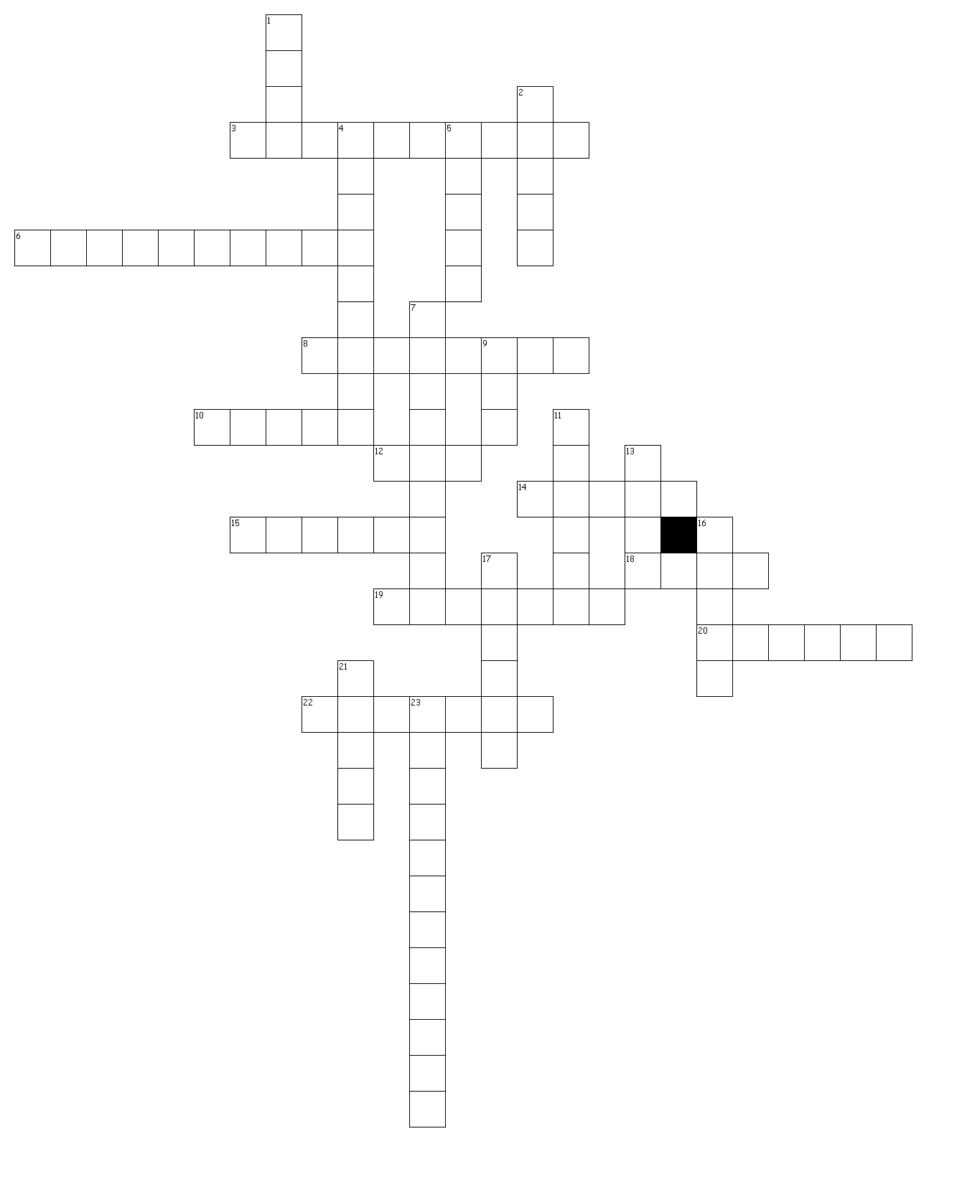

**Matter Crossword**

**Name___________________________**

**Date _____________________**

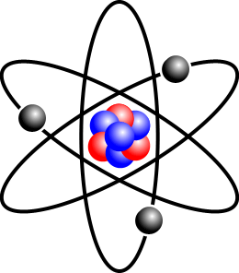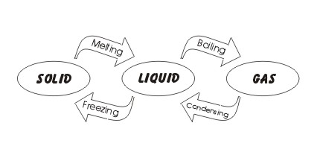

**WORD BANK**

atoms boils evaporate

snow solid container

float freezes gas

gasoline helium mass

ice ketchup lava

liquid volume oxygen

melts maple syrup

shape water vapor

carbon dioxide

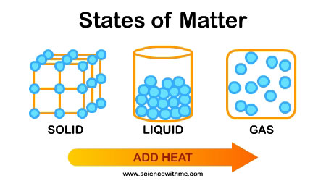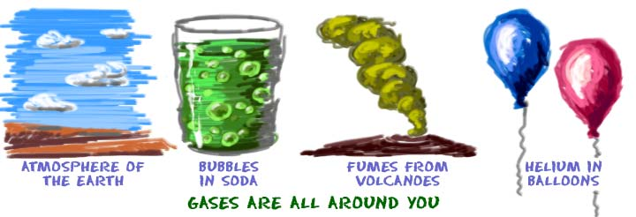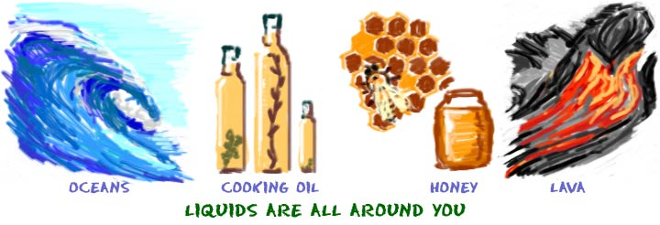Matter Crossword

**Across**

3. Water in the form of a gas is called _____.

6. This is a liquid that you might pour on pancakes or waffles.

8. This liquid is needed by most cars and trucks to run.

10. Solid matter does not change _____.

12. When atoms are in this state of matter, they fly around freely.

14. If you place a solid in a liquid, it will either sink or _____.

15. This is the type of gas that animals' bodies need to stay alive.

18. Solid white flakes of water that fall from the sky are known as ____.

19. At 0 degrees Celsius (32o Fahrenheit), water _____.

20. Raindrops are this state of matter.

22. You might pour this thick, red liquid on a hot dog or hamburger.

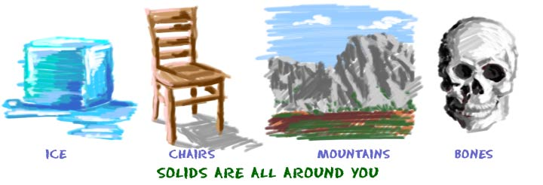 Clues

**Down**

1. This is liquid rock that pours out of a volcano.

2. Matter that has a definite shape and volume is in this state.

4. On a warm day, the liquid water in a puddle will _____ and turn into a gas.

5. The tiny particles that matter is made of are _____.

7. Liquid matter takes the shape of its ____.

9. Water, in solid form is _____

11. The amount of space that matter takes up is its _____.

13. The amount of matter something contains is its ______.

16. At 100 degrees Celsius (212o Fahrenheit), water _____.

17. This is a very light gas found in some balloons.

21. When a solid is heated up and turns into a liquid, it ____.

23. This is the type of gas that plants need to make food.