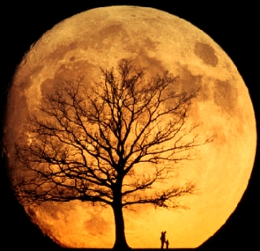
Moon Watch
Name_________________________________________Division_________ Due: ___________________
Directions:
Each night for the next seven nights… Look up!
Draw the moon as you see it in the boxes below. Use a pencil to shade in the areas of the moon that are dark and leave white the areas that are bright. Record the date and time of your observations. You should also record any important weather conditions (like clouds) or anything interesting you see in the night sky.

Date: | Date: | Date: | Date: | Date: | Date: | Date:
Time: | Time: | Time: | Time: | Time: | Time: | Time:
Other Observations: | Other Observations: | Other Observations: | Other Observations: | Other Observations: | Other Observations: | Other Observations:

Remember to check your homework @: www.msascienceonline.weebly.com

Moon Watch

Student Name: ____________________________________

Ms. Aeschlimann’s 6th Grade Science
Due: ___________________________

Go Outside! Breathe Fresh Air! Look Up!

