Photosynthesis Poster Rubric
You will create a poster illustrating key components of photosynthesis. The poster needs to have a drawing of a plant and the poster must include all of the following:
Name: ________________________________Date DUE: _________ Div: ________

Information needed  on poster | Your Answer | Possible Points | Your points
Poster includes an illustration of a Plant |  | 5 pts.
3 things necessary  for photosynthesis to happen:  (illustrate and label) |  | 30 pts.
Where do plants get the gas needed for this process?  (illustrate) |  | 5 pts.
What organelle is responsible for photosynthesis?  (illustrate close-up of organelle) |  | 5 pts.
What is the pigment found in chloroplasts?  (Label in close-up) |  | 5 pts.
Where does Carbon Dioxide enter and  Oxygen exit the plant?  (must have arrows on poster to show direction of gas movement) |  | 10 pts.
Where does water enter the plant?  (must have arrows on poster to show direction and labeled) |  | 5 pts.
Where does the energy come from for photosynthesis?  (Illustrate and Label) |  | 5 pts.
Describe glucose and where it is produced.  (Labeled with Description) |  | 5 pts.
Write the chemical equation for  photosynthesis |  | 10 pts.
Poster is colored and neat |  | 10 pts.
Name, date and division on poster |  | 5 pts.
Include this rubric completed with poster |  | + 10 pts.
 | Total Points: Up to 110 pts (A+)

Photosynthesis Equation

Equation: Carbon Dioxide + Water + Sunlight Glucose (Sugar) + Oxygen

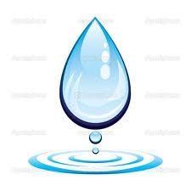
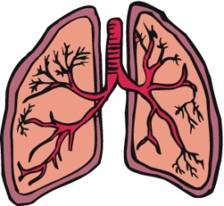
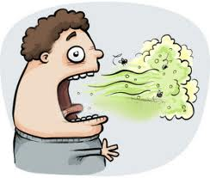
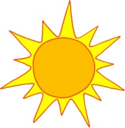
+ + +

Chemical Equation: CO₂ + H₂O + Energy C₆H₁₂O₆ + O₂

