Name____________________________________ Date________________ Division __________

The PROTISTS Files
Total Points: _____ 60

Ameba/Amoeba
Directions: Color the Ameoba according to the directions. Organelles can be identified based on their descriptions, locations, and the key.
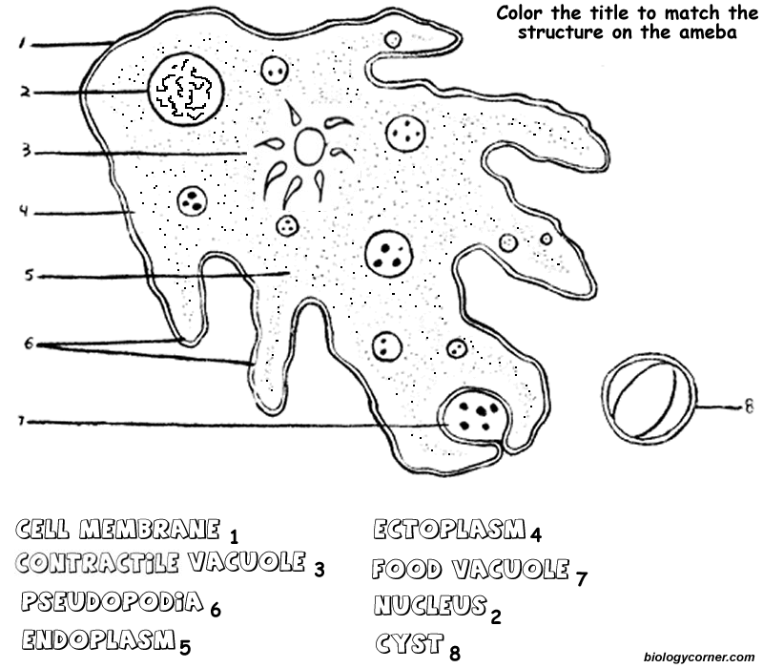
The ameba is a protozoan that belongs to the Kingdom Protista. The name ameba comes from the Greek word amoibe, which means change. (Amoeba is also spelled amoeba.) Protists are microscopic unicellular organisms that don't fit into the other kingdoms. Some protozoans are considered plant-like while others are considered animal-like. The ameba is considered an animal-like protist because it moves and consumes its food. Protists are classified by how they move, some have cilia or flagella, but the ameba has an unusual way of creeping along by stretching its cytoplasm into fingerlike extensions called pseudopodis (pseudopod). (The word "pseudopodia" means "false foot".) On the coloring sheet, there are several pseudopodia, use a yellow highlighter or pencil to highlight each of them (color around the outside of them). When looking at ameba under a microscope, an observer will note that no ameba looks the same as any other, the cell membrane is very flexible and allows for the ameba to change shape. Color the cell membrane red. Amebas live in ponds or puddles, and can even live inside people.
There are two types of cytoplasm in the ameba, the darker cytoplasm toward the interior of the protozoan is called endoplasm, and the clearer cytoplasm that is found near the cell membrane is called ectoplasm. (On the coloring, the endoplasm is indicated by the dotted area, and the ectoplasm by the white area.) Color the endoplasm blue, and leave the ectoplasm uncolored. By pushing the endoplasm toward the cell membrane, the ameba causes its body to extend and creep along. It is also by this method that the ameba consumes its food. The pseudopodia extend out and wrap around a food particle in a process call phagocytosis. The engulfed food then becomes a food vacuole. There are several food vacuoles on the drawing – color each brown. The food will eventually be digested by the cell’s lysosomes.
Also visible in the ameba is the nucleus, which contains the ameba's DNA. Color the nucleus purple. In order to reproduce the ameba goes through mitosis, where the nucleus duplicates its genetic material and the cytoplasm splits into two new daughter cells, each identical to the original parent. This method of reproduction is called binary fission. Another structure easily seen in the ameba is the contractile vacuole, whose job is to pump out excess water so that the ameba does not burst. Color the contractile vacuole orange.
During unfavorable conditions, the ameba can create a cyst, this hard-walled body can exist for a long period of time until conditions become favorable again. At this point it opens up and the ameba emerges. Often cysts are created during cold or dry periods where the ameba could not survive in its normal condition. Color the cyst green.
Amebas can cause disease. A common disease caused by the ameba is called Amebic Dysentery. A person becomes infected by drinking contaminated water. The ameba then upsets the person's digestive system and causes cramps and diarrhea. A person is most likely to be infected in countries where the water is not filtered or purified.
Questions:
1. How does an ameba move?
2. What structure contains the ameba's DNA?
3. How are protozoans classified?
4. During unfavorable conditions, an ameba forms a ... ?
5. Fingerlike extensions of the ameba's cytoplasm are called ...?
6. What disease is caused by the ameba?
7. To what Kingdom does the ameba belong?
8. How does an ameba reproduce?
9. Where does the word amoeba come from?
10. What does the word Pseudopod mean?

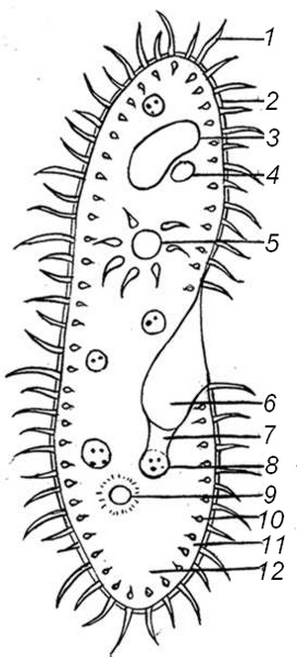
Paramecium
1. Cilia 2. Pellicle 3. Macronucleus
4. Micronucleus 5. Contractile Vacuole
6. Mouth Pore 7. Gullet 8. Food Vacuole 9. Anal Pore 10. Trichocysts

Directions: Color the Euglena according to the directions. Organelles can be identified based on their descriptions, locations, and the key.
Paramecium are unicellular protozoans classified in the phylum Ciliophora (pronounced sill-ee-uh-FORE-uh), and the Kingdom Protista. They live in quiet or stagnant ponds and are an essential part of the food chain. They feed on algae and other microorganisms, and other small organisms eat them. All members of the Phylum Ciliophora move by tiny hair-like projections called cilia. Color all cilia black. The paramecium cannot change its shape like the ameba because it has a thick outer membrane called the pellicle. The pellicle surrounds the cell membrane. Color the pellicle light blue.
There are two types of nuclei (plural of nucleus). The large nucleus is called the macronucleus which controls cell activities such as respiration, protein synthesis and digestion. Color the macronucleus red. The much smaller micronucleus is used only during reproduction, color the micronucleus pink. Reproduction in paramecium involves the exchanging of DNA within the micronucleus. In order to do this, two paramecium lie side by side and join at the mouth pore. This process is called conjugation and is a method of sexual reproduction in other microorganisms.
Contractile vacuoles are used in animal cells to remove the excess water. The contractile vacuole is shaped like a star - color the contractile vacuole dark green.
Paramecium are heterotrophs, meaning they must consume food for their energy. Food enters the paramecium through the mouth pore (color orange) and goes to the gullet (color dark blue). The area of the paramecium appears pinched inward and is called the oral groove, cilia sweep food into this area. At the end of the gullet, food vacuoles are formed. Food vacuoles then remain in the cytoplasm until the food is digested. Color all food vacuoles light brown. Undigested food particles are eliminated through the anal pore (color dark brown).
Paramecium can respond to temperature, food, oxygen and toxins and have a very simple defense mechanism. Just inside the pellicle are threadlike organelles called trichocysts. The paramecium can shoot tiny threads out of the cell to entangle a predator or to make themselves appear bigger. Color the trichocysts purple. Paramecium are also known to exhibit avoidance behavior. This is where the paramecium will move away from a negative or unpleasant stimulus like bright lights or acidic environments.
There are 2 kinds of cytoplasm in the paramecium. The cytoplasm around the edges is clear and is called ectoplasm. Leave the ectoplasm clear. The rest of the cytoplasm is more more dense and appears darker. This is called the endoplasm. Remember that the word "ecto" means outside, and the word "endo" means inside. Color the endoplasm yellow.
Questions:
1. Is the paramecium a unicellular or multicellular organism?
2. To what Phylum and Kingdom do paramecium belong?
3. Define heterotroph.
4. What do paramecium eat?
5. How do all members of the Phylum Ciliophora move?
6. Why can't the paramecium change shape like the ameba?
7. What do the macronucleus and micronucleus do?
8. Define conjugation.
9. What is the function of the contractile vacuole?
10. What is the oral groove?
11. Wastes exit the paramecium through what structure?
12. What is the function of the trichocysts?
13. Define avoidance behavior.
14. Where do paramecium live?

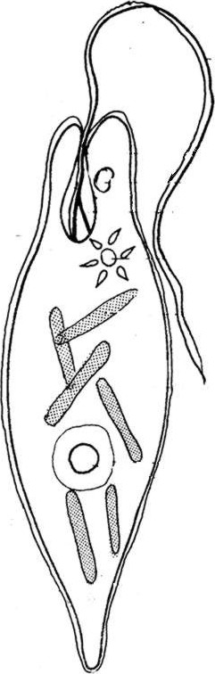
The Euglena
Directions: Color the Euglena according to the directions. Organelles can be identified based on their descriptions and locations.
Euglena are unicellular organisms classified into the Kingdom Protista, and the Phylum Euglenophyta. All euglena have chloroplasts and can make their own food by photosynthesis. They are not completely autotrophic though, euglena can also absorb food from their environment; euglena usually live in quiet ponds or puddles.
Euglena move by a flagellum (plural ‚ flagella), which is a long whip-like structure that acts like a little motor. The flagellum is located on the anterior (front) end, and twirls in such a way as to pull the cell through the water. It is attached at an inward pocket called the reservoir. Color the reservoir grey and the flagellum black.
The Euglena is unique in that it is both heterotrophic (must consume food) and autotrophic (can make its own food). Chloroplasts within the euglena trap sunlight that is used for photosynthesis, and can be seen as several rod like structures throughout the cell. Color the chloroplasts green. Euglena also have an eyespot that detects light, it can be seen near the reservoir and the flagellum. This helps the euglena find bright areas to gather sunlight to make their food. Color the eyespot red. Euglena can also gain nutrients by absorbing them across their cell membrane, which means they become heterotrophic when light is not available, and they cannot photosynthesize.
The euglena has a stiff pellicle outside the cell membrane that helps it keep its shape, though the pellicle is somewhat flexible and some euglena can be observed scrunching up and moving in an inchworm type fashion. Color the pellicle blue.
In the center of the cell is the nucleus, which contains the cell's DNA and controls the cell's activities. The nucleolus can be seen within the nucleus. Color the nucleus purple, and the nucleolus pink.
The interior of the cell contains a jelly-like fluid substance called cytoplasm. Color the cytoplasm light yellow. Toward the flagellum end of the cell is a star-like structure: the contractile vacuole. This organelle helps the cell remove excess water, and without it the euglena could take in so much water that the cell would explode. Color the contractile vacuole orange.

Questions:
1. Are euglena unicellular or multicellular?
2. What Kingdom do euglena belong to? What Phylum?
3. What organelle carries out photosynthesis?

4. Define autotrophic.

5. Define heterotrophic.

6. Describe the two ways in which the euglena get their nutrients.

7. What is the eyespot used for?

8. What is the function of the nucleus?

9. What is the function of the contractile vacuole?
10. What would happen if the cell did not have this organelle (the contractile vacuole).

Edited from: http://www.biologycorner.com/
