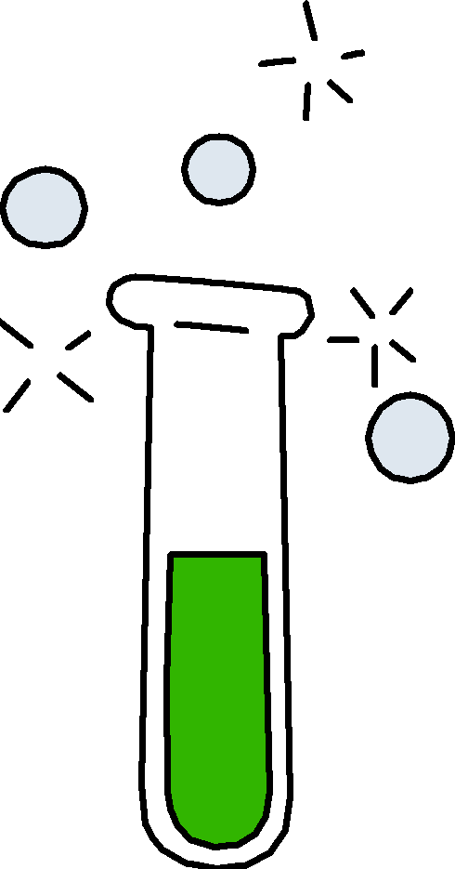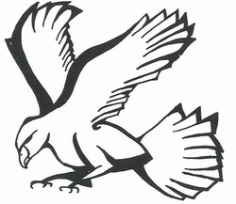

**2012 - 2013**

Experimenter: __________________________

Grade: _____________________

If lost, please return to

Ms. Aeschlimann’s Science Class, Room 216

Rumney Marsh Academy, Revere MA