Notes on Section 2-2: Bacteria
The Bacterial Cell
- Bacteria are nearly everywhere on Earth and in all living things
- Anton van Leeuwenhoek first discovered bacteria when looking at scrapings from his teeth under a microscope
- Bacteria are classified as organisms called prokaryotes
- Prokaryotes are organisms that do not have their genetic material located in a nucleus (the opposite of this are called eukaryotes)
- Each bacterial cells uses energy, grows and develops, responds to its surroundings, and reproduces
  - Cell Shapes
    - The three basic shapes of bacteria are: spherical, rodlike and spiral
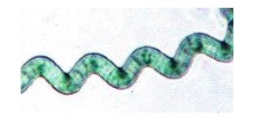

**Draw these in your notes
    - The shape helps identify the type of bacteria
  - Cell Structures
    - Bacterial cells have a cell wall, cell membrane, cytoplasm and ribosomes (organelles that make proteins)
    - There is NO nucleus (the genetic material is located in the cytoplasm and looks like thick, tangled string)
    - The genetic material (DNA) controls everything the cell does
    - 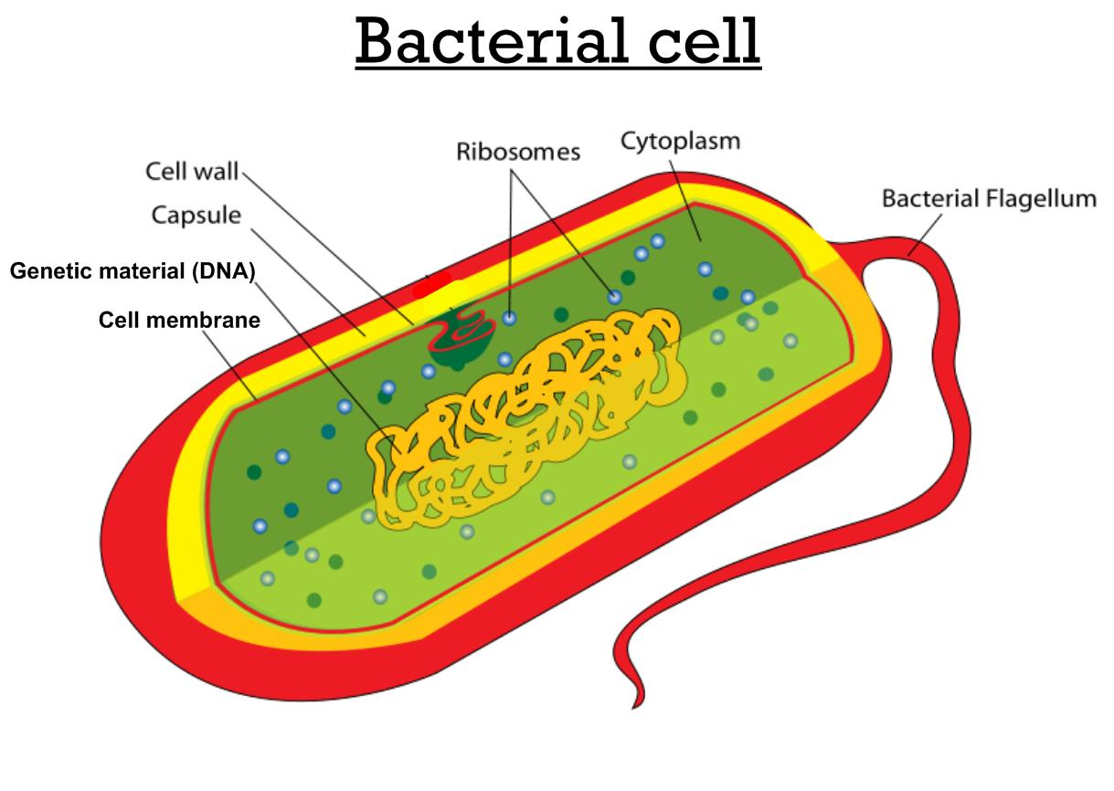Bacterial cells have a flagellum (plural = flagella), which is a long, whip-like structure that helps the cell to move by spinning in place like a propeller

Two Kingdoms of Bacteria
- Archaebacteria
  - Ancient types of bacteria (existed billions of years before the dinosaurs)
  - Live in extreme environments like hot springs, places that are as acidic as lemon juice, salty waters, animal intestines, bottom of swamps and sewage
- Eubacteria
  - Do not live in extreme environments
  - Live everywhere else (like in and on your body)
  - Most are harmless
  - Some help maintain Earth’s physical conditions (like producing oxygen for the atmosphere)
Reproduction in Bacteria
- When all of their needs are met, bacteria can reproduce once every 20 minutes
- Growing conditions are rarely ideal for bacteria (which is a good thing!)
  - 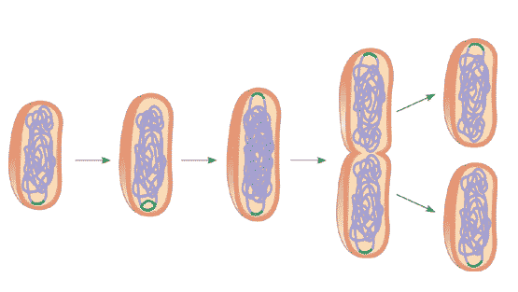Asexual reproduction
    - Some bacteria reproduce by binary fission, which is a process in which one cell divides to form two identical cells
    - Type of asexual reproduction, which is a way that an organism reproduces that only involves one parent
    - Offspring (new bacteria) are identical to the parent
    - Offspring have the same genetic material (DNA) as the parent
  - Sexual reproduction
    - A way that an organism reproduces that involves two parents who combine their genetic material to produce a new organism
    - Offspring is different from both parents
    - Conjugation
      - 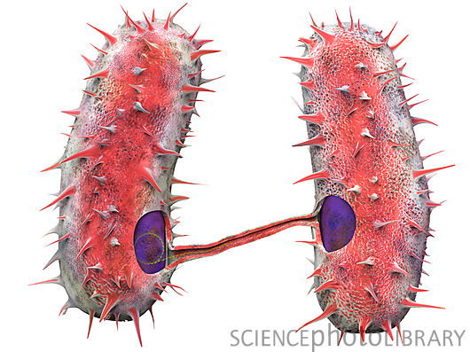When one bacterium transfers some of its genetic material into another bacterial cell
      - Uses a thin, threadlike bridge that joins the two cells
      - An example of sexual reproduction in bacteria
      - Results in offspring (new bacteria) with a new combination of genetic material (DNA) that are genetically different from their parents

Survival Needs
- All bacteria have basic needs of survival: food, way to break down food to release energy and survival techniques when living conditions become difficult
- Obtaining Food
  - Autotrophic bacteria make their own food either by
    - Capturing and using the sun’s energy as plants do
OR BY
    - Using the energy from chemical substances in their environment
  - Heterotrophic bacteria consume autotrophs or other heterotrophs
    - Eat a variety of foods, like milk, meat and decaying leaves on the ground
- Respiration
  - Respiration is the process of breaking down food to release its energy
  - **This is another meaning of the word “respiration” that we learned earlier in the year (exchanging gasses).
  - Most bacteria need oxygen to break down food
  - Some bacteria do NOT need oxygen to break down food (oxygen is poisonous to them)
- Endospore Formation
  - An Endospore is a small, rounded, thick-walled resting cell that forms inside a bacterial cell
  - Contains the cell’s genetic material (DNA) and some of its cytoplasm
  - Endospore can resist freezing, heating and drying and can survive for many years
  - Forms to allow bacteria to survive harsh living conditions
  - Are lightweight so a breeze can carry them to new places
  - If conditions are better there, it will open up and bacterial cell can grown and multiply

Bacteria and the Living World
- Some bacteria can cause illness, but most bacteria are harmless or helpful to people
- Bacteria are helpful by involved in making fuel and food, environmental recycling and cleanup and the production of medicines
- Fuel
  - Methane gas is produced from archaebacteria that died millions of years ago
  - The bacteria lived in oxygen-free environments (like mud from swamps)
  - This gas makes up about 20% of the Earth’s natural gas (which is used to heat homes)
- Food
  - Bacteria are used to make cheese, yogurt, apple cider, pickles, and more
- Environmental Recycling
  - Heterotrophic eubacteria are examples of decomposers, organisms that break down large chemicals in dead organisms into small chemicals
  - “Nature’s recyclers” – returning basic chemicals to the environment for other organisms to use (ex. When bacteria break down leaves that fall to the ground)
  - Some bacteria help plants like peanuts, peas and soybeans to convert the nitrogen in the air into a form that they can use
- Environmental Cleanup
  - Some bacteria eat oil as their food source, and this can be used to help clean up oil spills
- Health and Medicine
  - Some bacteria in our digestive system helps us to digest our food
  - Other helpful bacteria in our intestines prevent harmful bacteria from growing there
  - Scientists used bacteria to help make medicines (insulin) for people who have diabetes
  - Started in the 1970’s

